
ENGLISH COURSE

Year 1 - UNIT 3
teacher : Anne SOMBART
2020-2021

I. Internet basics.
- Listen to the audio document. What is it ? Where does it take place ? What is it about ?

It is a conversation between a sellsmen who wants to sell a pc and a women and she is asking questions about how it works to him (epecially about internet). It takes place in a shop.

- Listen again and complete the following notes :

To connect to the Internet from home, I need :
(1) a computer and (2) a modem.
Also need an account with an (3) ISP (Internet Service Provider) (a company that offers connection for a monthly fee).
If you want to connect lots of computers without using cables, you can use a (4) wireless router.
Wi-fi uses (5) radio waves to send data over medium-range distances.
Things you can do on the Internet :
(6) Email, file transfer, news groups, real time chat, instant messaging, looking for information on the web.
'Web' or 'Internet' ? The web : huge collection of (7) pages stored on computers all over the world. The Internet : the network which connects all the computers.

II. Internet FAQs
- Read part 1 of the Internet FAQs and choose the correct answers.
1. The Internet was
a. invented in the mid-90s b. popular in the 1960s c. probably created in the USA
- Which term describes any fast, high bandwidth connection ?
a. broadband b. dial-up connection c. wi-fi connection
- The power-line Internet provides broadband access through
a. telephone lines b. satellites c. electrical power lines
- Which devices converts computer data into a form that can be translitted over phone lines ?
a. ADSL b. a mobile phone c. a modem
- The standard protocol that allows computers to communicate over the Internet is called
a. an IP address b. TCP/IP c. HTTP
- The geographical region covered by one or several access points is called a
a. wireless access point b. hotspot c. wireless network device

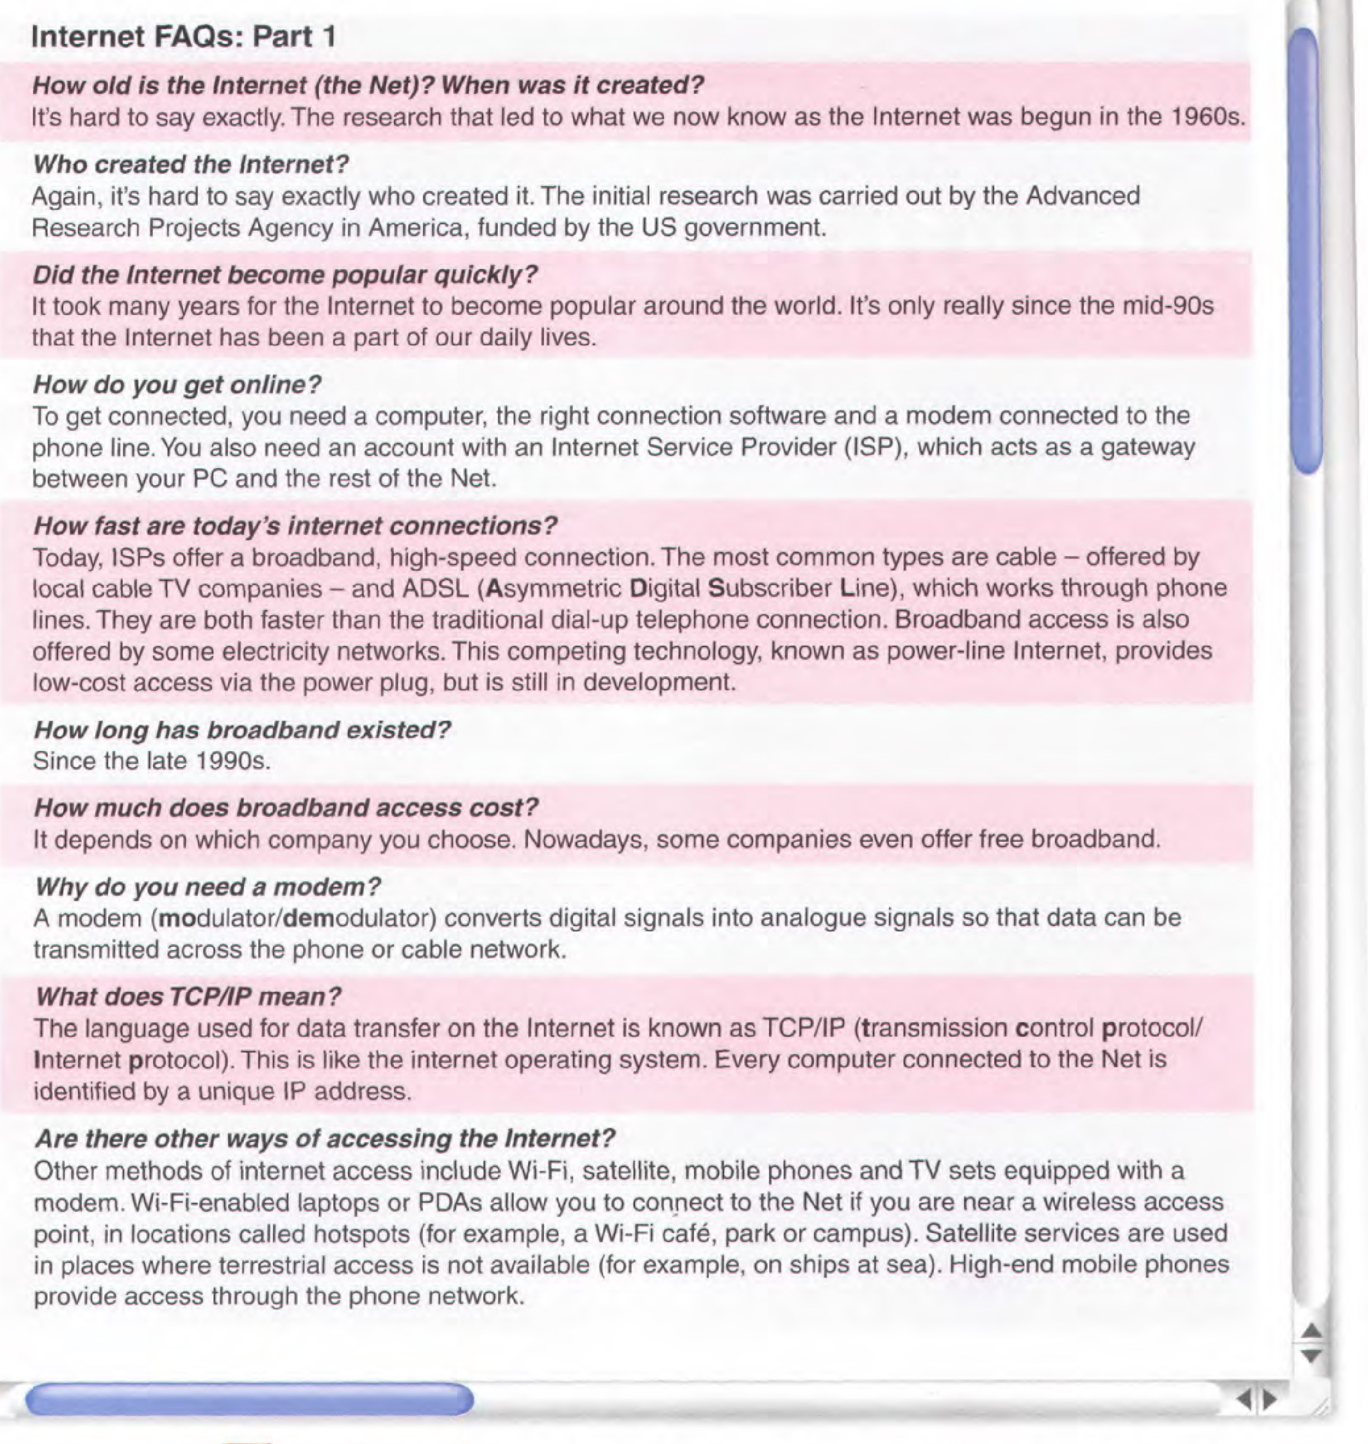
- Decide which of the internet systems (1-6) you would use to do the tasks (a-f). Then read part 2 of the FAQs to check your answers.

- email
- the Web
- newsgroups
- chat and IM
- FTP
- Telnet

a. transfer files from the Internet to your hard drive
b. send a message to another person via the Internet
c. have a live conversation (usually typed) online
d. connect to a remote computer by entering instructions, and run a program on it
e. take part in public discussion areas devoted to specific topic
f. download and view documents published on the Internet
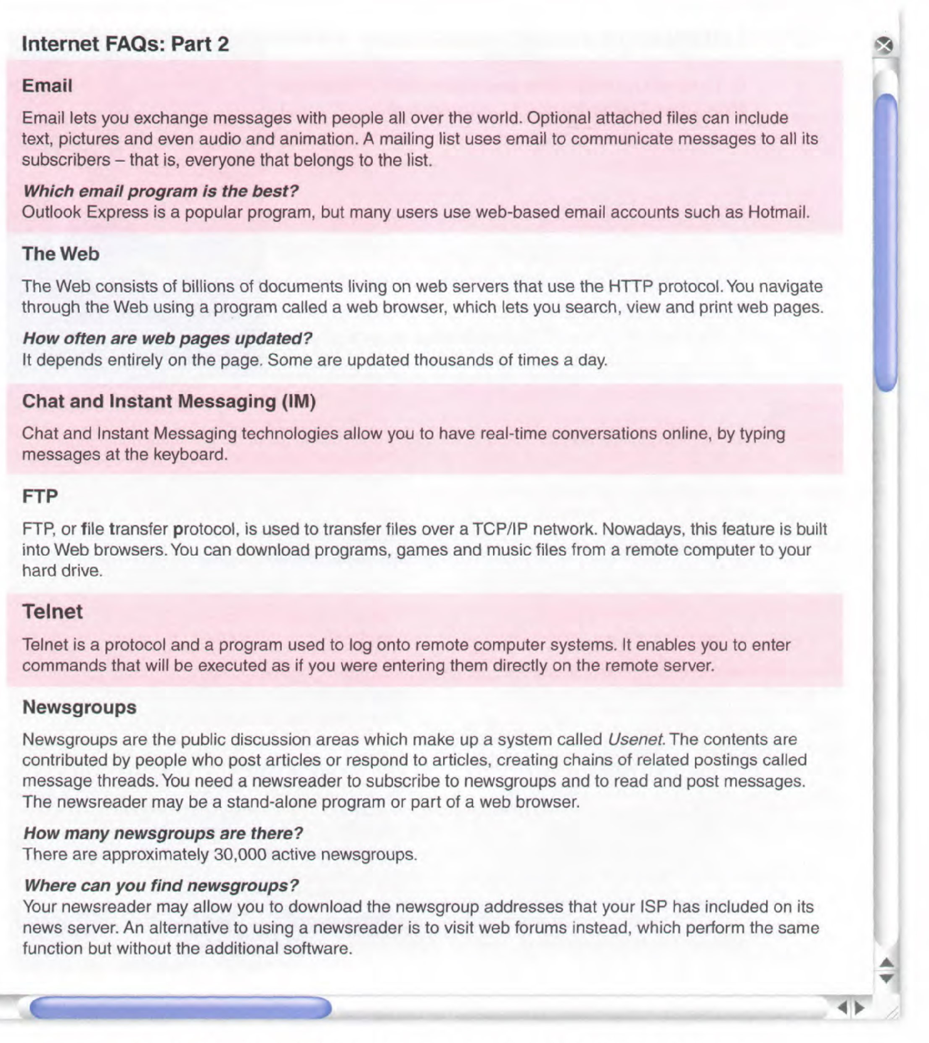

- Find words and phrases in part 2 with the following meanings :
- a system used to distribute email to many different subscribers at once : mailing list
- a program used for displaying web pages : web browser
- to connect to a computer by typing your username and password : to log onto
- a series of interrelated messages on a given topic : thread
- a program for reading Usenet newsgroups : Newsreader

- Study this URL (Uniform Resource Locator)

- Read the paragraph about how your browser finds the webpage you want. Then label the items on the diagram.

To find the webpage you want, you have to click on a webpage hyperlink or enter a URL, a Uniform Resource Locator into a browser. The URL is the address of the page. When you do that, the browser sends the URL to a DNS server. The DNS server is the Domain Name Server. It uses a look-up table to find the IP address of the Web server referred to in the URL. The IP address is a unique, 32-bit, set of numbers. Erm, every computer on the Web has its own IP address. Once the DNS server has found the IP address, it sends it back to the browser. The browser then uses this IP address to send a request to the Web server. The request is sent as a series of separate data packets which include both the IP address of the Web server and the IP address of the browser computer. These data packets are first sent to a router computer, which uses the IP address of the Web server to determine the best available route for each packet. The packets are passed from router to router until they reach the Web server. They may travel by different routes before reaching the server. As the individual packets reach the Web server, they're put back together again. The Web server now services the request by sending the requested webpage back to the browser computer. Again it travels as a series of separate data packets from router to router. This time the router uses the IP address of the browser computer to work out the best available path for each packet. As the packets arrive at the browser computer they're combined to form the webpage you requested and are displayed in your browser.

- Language work

Complete each gap in these sentences with the -ing form of an appropriate verb from this list :

back up / become / enter / find / keep up / learn / link / receive / select / send / use

- Keeping up with the latest news on your favourite team is esay on the web.
- One of the most useful features of the Internet is receiving and sending email.
- The grandfather, father, son method is one way of backing up your documents.
- Fibre-optic cable can be used for linking computers in a network.
- Search engines are ways of finding information on the Web.
- Using a keyboard is the most common way of entering data into a computer.
- Sending audio and video attachments is possible with email.
- Becoming a programmer means learning a number of programming languages.
- The White Pages are for finding email addresses.
- Selecting an option in a menu is easy with a mouse.

- Websites

1. Decide which of the sites (a-j) to visit in order to find information on the following topics (1-10)

- the latest scientific developments
- caring for your cat
- calculating your tax
- new cars
- advertising on the web
- books on sport
- sending a virtual greeting card
- economic data on Bulgaria
- your horoscope
- ski conditions in Europe
a. www.admarket.com
b. www.bubble.com/webstars/
c. www.buildacard.com
d. www.carlounge.com
e. www.encenter.com
f. www.petcat.co.uk
g. www.moneyworld.co.uk
h. www.newscientist.com/
i. www.thebookplace.com
j. www.worldbank.org

- Study these 7 points for evaluating websites. How woud you evaluate a website on each point ?

Design is important because it is what attracts the user, it will make the user stay on the website. It is what gives the user his first impressions. There mustn’t be too much elements, or it is confusing, so particular attention must be given to the layout. The choice of coulours is very important, it must not look agressive but be clear and sober.

A graphic charter is necessary when designing a website. Navigation must be easy for the user, user-friendly.
Information needs to be found easily and everything must be understood at once. Links and buttons must be clear.
User mustn’t be scared away, so the functions must be easily understandable and the pages of the website must be consistant so that the user won’t get lost.
The website must be ergonomic and intuitive.
The information must be up-to-date but you don’t have to be too precise or the website will be loaded with too much information, and again the user might get lost, so it’s a question of balance between the amount of information and ease of use. Graphics can be useful on some website, for example for statistics and figures. They will help the user to understand, they can replace symbols that are understood by everybody are used. When graphics do not serve any purpose, they are unless and shouldn’t be used.
The website must be optimised for smartphones and tablets and also for blind people.

3. Study these extract from a text. Decide :
- what special expertise does the author have in this field ? webdesign expertize
- Who are the intended readers ? People who are insterested in creating a website and design it.
- What is the author's purpose ? It’s to allow people to have smoother and well structured websites

- Work in groups of 3. Summarise the advice in each text you read in one sentence.

student A : read texts 1 to 3
student B : read texts 4 to 6
student C : read texts 7 to 9

1 - Text links are more likely to get clicked than images
2 - Descriptive ALT text captions and text links at the bottom of an image are very important to find our way around
3 - A sit map allows people to regroup their ideas so they are more accessible and presented in a better way
4 - Don’t put too many frames because it can be confusing for visitors. Need to create a website without frames for people whose browsers does not support frames.
5 - It’s about the location and the color of various elements in a page. You should not confuse the user by changing the location/color of an element in differents pages of your website.
6 - You need a maximum counts of 4 clics on a website to find the information you want, if not then you need te rearrange your website in a way that people can reach what they want in fewer clics
7 - You have to try to discourge users to use « search fonction » cause they are not usualy optimal
clearly placed links are better to help the visitor.
8 - You can use a pull down navigation menu cause it’s easy to understand, to take in charge and without wasting space.
9 - Don’t overwellm the user w/ dozens of pages and else cause it can be confusing...

LISTENING COMPREHENSION

1. Before listening, match the following words with their definition :

book •

endorsement •
fake •
growth •
review •
sample •
trick •
valuable •
unlawful •
watchdog •

• an organization that makes sure that companies, governments,etc are not doing anything illegal
• illegal
• deceive
• reserve in advance
• increase, expansion
• a small amount of something
• a statement of support or approval
• a report that gives someone's opinion
• not true or real
• very useful or helpful

2. Listen to the recording and tick the correct answers

❶ What kind or organisation reported on the fake online reviews ?
- A group of dogsbodies
- the Doggy Bag club
- The UK Hounddog Association
- a consumer organization

❷ What did the CMA say these reviews are designed to do ?
- educate customers
- trick customers
- fake customers
- make customers poor

❸ How many British people read online reviews ?
- 25 %
- 35 million
- 25 million
- half

❹ What do some companies use as a marketing tool ?
- reviews
- money
- plumbers
- consumers

❺ What do some companies offer in exchange for five-star reviews ?
- loyalty cards
- free samples
- discounts
- endorsements

❻ How much spending in the UK could be affected a year by fake reviews ?
- £26 million
- £36 million
- $26 million
- $36 million

❼ Who said millions of people look at online reviews ?
- a reviewer
- a website owner
- an industry analyst
- a CMA spokeswoman

❽ What kind of practices did the CMA hear about ?
- illegal practices
- valuable practices
- model practices
- rival practices

❾ What kind of companies write negative comments on other companies ?
- illegal companies
- service companies
- rival companies
- plumbing companies

❿ What could happen to bosses who write negative reviews ?
- They could get promoted
- They could go to jail
- They could get negative reviews
- Not much

3. Put the words in the correct order to write sentences.

a. of sites millions on hotels are reviews for there
________________________________________________________________________________________
b. websites at in Britain reviews 25million least read people on
________________________________________________________________________________________
c. industry in writes a there that the reviews is growth fake
________________________________________________________________________________________
d. reviews themselves many about fake companies write
________________________________________________________________________________________
e. five-star or money exchange offer free companies for reviews in samples
________________________________________________________________________________________
f. important businesses to reviews online are very
________________________________________________________________________________________
g. be reviews consumer by speding online could influenced
________________________________________________________________________________________
h. reviews find consumers online them use valuable who
________________________________________________________________________________________
i. each post other negative remarks rival about companies
________________________________________________________________________________________
j. prison unlawful could to practices bosses going for face
________________________________________________________________________________________

4. Listen again and complete with the missing words

A consumer watchdog in the UK has reported that many Internet _____________(1) are full of fake reviews. The UK's Competition and Market ____________________(2)(CMA) believes there are millions of reviews on sites for _________________(3), restaurants, theatres and online store that have been paid for to trick _________________(4). it is said that at least 25 million people in Britain read reviews on websites such as Amazon and Tripadvisor before booking ___________________(5) or doing online shopping. The CMA found there was a __________________(6) in the industry that writes fake reviews for companies and businesses. Many companies _______________(7) fake reviews about themselves as a marketing tool. Others _______________(8) money, free samples or upgrades in exchange for five-star reviews.
Online reviews are very important to businesses. Industry ________________(9) estimate that in Britain alone, $36 billion a year of consumer ________________(10)could be influenced by online reviews. A CMA spokeswoman said : ''Millions of peoplelook at online reviews and _________________(11) before making decisions such as where to stay on holidday or which __________________(12) to use.'' She _________________(13) :''We have found that consumers who use online reviews and endorsements find them ____________________(14), but we have also heard about some practices that may be ____________________(15).'' Some of the more illegal activity includes ________________(16) companies posting negative remarks about each other's goods and ________________(17). Bosses could __________________(18)
going to prison for doing this.

WRITING
Study the Internet statistics and write a paragraph (≈150 words) about your findings.
Make sure of the proper use of tenses (present simple / continuous, simple past, present perfect) and time expressions (… ago / for … / since …)

